Life is a Cookbook Rough Draft
Directions: Use the following template to create your rough draft for your Life is a Cookbook Assignment.
Title: ________________________________________________
Illustration:
Ingredient List:

- Include at least five ingredients.
- Be sure to include kitchen nouns (TBSP, tsp., cups).
- You must be able to explain why you use certain
amounts of each ingredient.
___________________________________________________________________________________________________________________________________________________________________________________________________________________________________________________________________________________________________________________________

Instructions:
- Write the steps to the recipe in order.
- Be sure to include at least five well chosen cooking verbs.
- Make the verbs stand out by highlighting, underlining, or coloring them.
__________________________________________________________________________________________________________________________________________________________________________________________________________________________________________________________________________________________________________________________________________________________________________________________________________________________________________________________________________________________________________

Peer Editing:
Before beginning your final copy in your notebook, you should have your recipe edited by a classmate. Your classmate needs to read your recipe and complete the following checklist:
- Spelling/grammar is correct.
- At least five ingredients are included.
- Kitchen nouns tell how much of each ingredient is needed.
- The steps to the recipe make sense.
- The instructions use well chosen cooking verbs that are highlighted, underlined, or colored.

Peer Editor’s Name: _____________________ Peer Editor’s Name: _____________________

Life is a Cookbook Directions
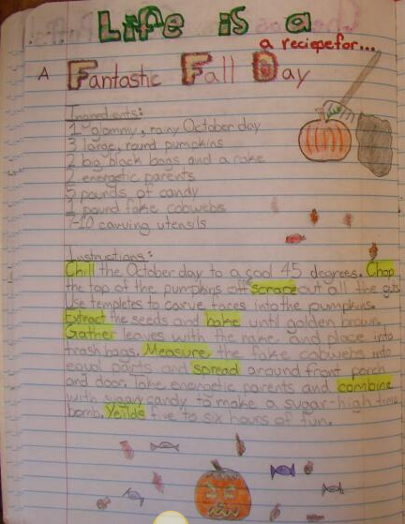
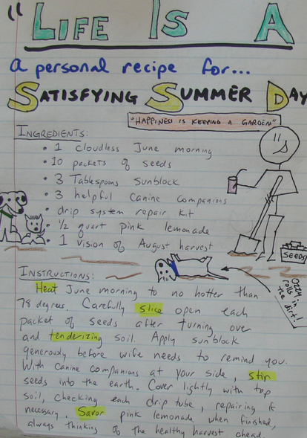

Life is a Cookbook Rubric Total: ________/50
Ingredients | The recipe includes a list of at least 5 ingredients. | The recipe contains only 3-4 ingredients. | The recipe contains 1-2 ingredients. | The recipe is missing an ingredient list.
Instructions | The recipe contains well written instructions that make sense for the recipe. The instructions include Kitchen Nouns. | The recipe contains well written instructions, but they do not make sense for the recipe OR are missing Kitchen Nouns. | The recipe contains instructions, but they do not make sense for the recipe AND are missing Kitchen Nouns. | The recipe is missing instructions.
Cooking Verbs | The recipe contains at least 5 verbs. | The recipe contains only 3-4 cooking verbs. | The recipe contains 1-2 cooking verbs. | The recipe contains no cooking verbs.
Spelling/Grammar | The recipe is free of spelling/grammar errors. | The recipe contains only 1-2 spelling/grammar errors. | The recipe contains 3-4 spelling/grammar errors. | The recipe contains over 5 spelling/grammar errors.
Illustration | The recipe includes a related neat and colorful illustration. | The recipe includes an illustration, but it is not one of the following: colorful, neat, or related. | The recipe includes an illustration, but it is not two of the following: colorful, neat, or related. | The recipe includes an illustration that is not colorful, neat, or related.

