January Monthly Project:
Exploring a Metaphor

Directions: A metaphor compares something to something else, and a good writer explains his/her comparison with thoughtful words. Today, you’ll be thinking of something important to you (your TOPIC) and then you will compare this one thing with four other things. There are four parts to this assignment. Make sure you complete all four parts.

Part 1 - Selecting Abstract and Concrete Nouns
Metaphor Topic:
(an abstract noun)

Eight different concrete nouns you might compare your topic to:
(For your metaphors, you’ll choose your four best ideas).

Part 2 – Writing Your Metaphors
Directions: When you have eight nouns, with a friend or family member, talk over which four would make the best comparisons for a descriptive metaphor. Circle the four you plan to use. Ask, “Would any of the nouns I use be improved if I put an interesting adjective in front of them?” Write your four metaphors (and adjectives if you’ve chosen any) below. (Example: A memory is a freshly-laid chicken egg). For each metaphor, write two details that explain it.
Metaphor 1: | Metaphor:  Detail 1:  Detail 2:
Metaphor 2: | Metaphor:  Detail 1:  Detail 2:
Metaphor 3: | Metaphor:  Detail 1:  Detail 2:
Metaphor 4: | Metaphor:  Detail 1:  Detail 2:

Part 3: Rough Draft/Editing
Directions: Create a rough draft for your metaphors on a sheet of blank paper. You can organizer your metaphors into the four corners or in any way you like. Make sure your rough draft meets all of the requirements listed in the following checklist. Have a friend/family member edit your rough draft using the checklist. You will submit this checklist and your edited rough draft with your final project.

Editing Checklist
Editor: ________________________________ | YES | No
There are a total of four metaphor poems.
Project contains a neat, colorful, and relevant title.
Each metaphor is about the same abstract noun.
All metaphors compare the abstract noun to a concrete noun.
Each metaphor contains two details that explain it.
Each metaphor contain a visual that represents it.
All metaphors are free of spelling/grammar errors.
All metaphors are neat and easy to read.

Part 4: Final Copy
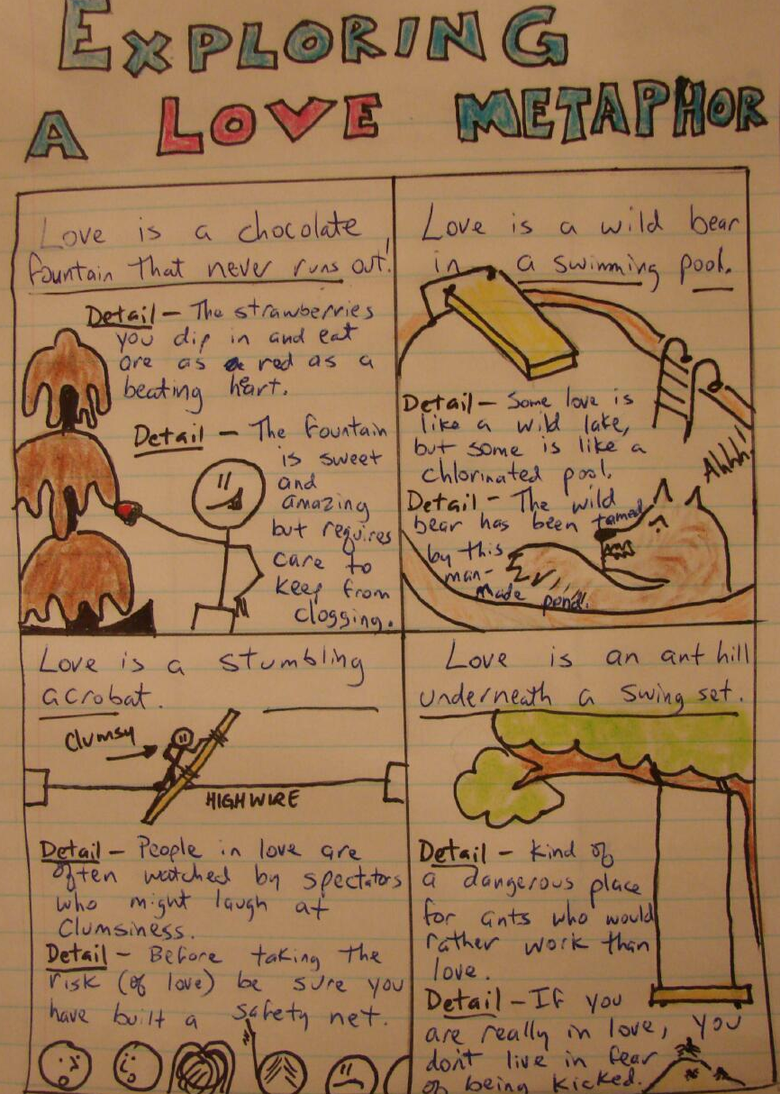
Directions: Once you’ve completed your rough draft and had it edited, begin working on your final copy. Following is an example of a final copy:
Make sure you submit all of the following by the due date of _________________.
- Completed graphic organizer (front of this sheet).
- Completed Rough Draft (separate sheet).
- Completed editing checklist (above).
- Final copy (separate sheet).

