Directions: After reading and annotating the graph, complete the What I See/What It Means chart and answer the questions.
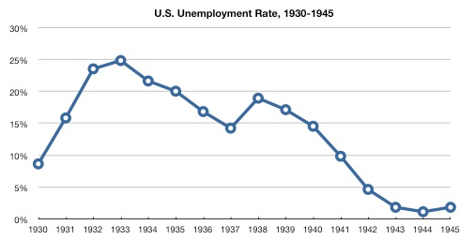

Bureau of Labor Statistics , “Graph of U.S. Unemployment Rate, 1930-1945,” HERB: Resources for Teachers, accessed October 30, 2016, https://herb.ashp.cuny.edu/items/show/1510.
What I See | What It Means
1.  2.  3. | 1.  2.  3.

1. The Great Depression began October 1929. What does the graph tell you about unemployment rates following the start of the Great Depression?

2. Franklin D. Roosevelt took office as president in 1933 and enacted The New Deal. How did this affect the unemployment rate?

3. In what year was the unemployment rate the highest? How high did it become?

4. What happened to the unemployment rate between 1937 and 1938?

5. WWII began in 1939. How did this affect the unemployment rate?

