Vocabulary Collecting Entry
Vocabulary Antonym & Synonym Directions

Directions: Follow this sheet in order to earn high scores on your vocabulary collection.
Requirements for your entries:
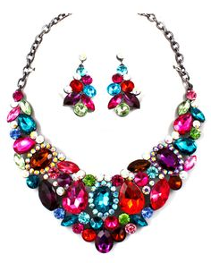
- Write the word in color and spell it correctly.
garish (adj) — tacky; bright and showy
- from Antonym/Synonym PowerPoint
Antonyms:
gaudy
meretricious
lurid

Synonyms:
subtle
inconspicuous
tenuous

- Correctly identify the part of speech.
- Define it in words that sound like your own words.
Vocabulary Haiku Rubric:
1 point | The antonyms and synonyms are all spelled correctly.
1 point | The antonyms and synonyms are all the same part of speech.
1 point | The antonyms and synonyms are all 10 or 25 cent words.
1 point | The antonyms and synonyms are presented in a neat and colorful way.
- Identify where you read or heard the word. Remember, book titles are always underlined.

- Create a “meaningful writing task” to show you can use the word. Use the rubric below to get full points for this task:

